Technology M&A Intelligence: Trends, Acquirer Profiles, Leadership Dynamics, Value Creation, and Integration Risks

Executive Summary
Technology M&A is dominated by a small cohort of serial acquirers whose disciplined, high-frequency deal strategies consistently outperform peers — and the path to value creation runs directly through integration execution, not deal volume alone. Analysis of 1,643 acquisitions by 36 major technology companies [1], combined with current market intelligence, reveals that Cisco (162 deals), Google (161), and Microsoft (136) account for a disproportionate share of activity, with serial acquirers delivering more than 11% higher total shareholder returns than occasional acquirers and growing up to three times faster than organic-only competitors [2, 3]. The market has accelerated sharply, with AI emerging as the primary catalyst — over 11,000 AI-linked acquisitions since 2020 [4] — pushing global tech deal value past $630 billion in 2025 [5, 6].
Yet more than half of tech deals add little or no shareholder value within two years [7], and the central risk is human, not technical: 67% of integration leaders cite cultural misalignment as the top barrier to capturing deal value [8], while 47% of key employees depart within the first year post-merger [9, 10]. Revenue synergies consistently fall 20–23% short of targets and require three to five years to materialize [11, 12], meaning acquirers who set realistic expectations and invest early in talent retention and cultural alignment dramatically improve outcomes. Governance patterns reinforce this: acquirers maintain significantly larger boards (averaging 8.9 versus 5.5 members for targets) [13], but board effectiveness and diversity — not size — correlate with better M&A results [14], and gender representation remains critically low at just 4.7% [13]. The most actionable insight is that companies should treat integration planning, particularly cultural assessment and retention incentive design, as a due diligence priority rather than a post-close afterthought, as execution quality is the decisive factor separating top-quartile deals generating 26% relative returns [7] from the majority that destroy value.

Introduction
Technology mergers and acquisitions have become the primary engine of strategic growth in the global technology sector. This report presents a comprehensive analysis drawing from an internal dataset of 1,643 acquisitions executed by 36 major technology companies between 1988 and 2014 [1], supplemented by external market intelligence covering the current M&A landscape through 2026. The analysis arrives at a pivotal moment: global M&A reached approximately $4.93 trillion in 2025, with technology deals alone exceeding $630 billion driven by more than 800 transactions [5, 6]. Artificial intelligence has emerged as the single biggest catalyst behind this surge, fundamentally reshaping how companies approach acquisitions [15].
This report examines five critical dimensions of technology M&A: acquisition trends and market dynamics, the characteristics of highly acquisitive companies, leadership and governance patterns, value creation opportunities, and technology integration risks. Each section synthesizes dataset-level evidence with broader market research to deliver actionable insights for acquirers, targets, and investors navigating the technology M&A landscape.

Technology Acquisition Trends and Market Dynamics
Historical Deal Volume and Acceleration. The internal dataset reveals a clear acceleration in technology M&A activity from the mid-2000s onward, with deal volumes rising sharply as major technology companies adopted acquisition-driven growth strategies [1]. The earliest recorded transaction dates to 1988, with Apple acquiring Network Innovations, while the most recent entries extend to 2014, including Amazon’s acquisition of Twitch for $970 million [1]. Several landmark megadeals punctuate the dataset: AOL’s acquisition of Netscape for $4.2 billion in 1998, Adobe’s purchase of Macromedia for $3.4 billion in 2005, Apple’s acquisition of Beats Electronics for $3 billion in 2014, and Adobe’s acquisition of Omniture for $1.8 billion in 2009 [1].
Geographic Concentration. Acquiring companies in the dataset are overwhelmingly U.S.-based, with California cities — San Jose, Mountain View, Sunnyvale, and Cupertino — dominating the headquarters landscape [16]. Only four non-U.S. acquirers appear: SAP (Germany), Vodafone (United Kingdom), Samsung (South Korea), and BlackBerry (Canada) [16]. This geographic concentration reflects Silicon Valley’s enduring role as the epicenter of technology innovation and deal-making, though cross-border acquisitions represent a meaningful share of activity, as discussed in the integration risks section.
The AI-Driven Surge and Sector Hotspots. The current M&A environment has been transformed by artificial intelligence. According to BCG, 11,372 of 41,149 majority technology acquisitions since 2020 are linked to the AI ecosystem, with strategic dealmaking broadening from buying technology and talent to assembling platforms at scale [4]. AI was identified as the single biggest catalyst behind the 2025 M&A surge, which pushed global deal value to a record $4.9 trillion [15]. Average deal sizes in technology have risen substantially, from $525 million in 2024 to approximately $779 million in 2025 [6]. Cybersecurity M&A also reached all-time highs in both deal volume and value in 2025, with strategic buyers deploying capital across identity management, cloud security, and data security [17]. Through September 2025, there were 144 large deals valued between $1 billion and $5 billion and 47 megadeals exceeding $5 billion, on pace for 17% more large deals and 31% more megadeals than the prior year [18].

Characteristics of Highly Acquisitive Companies
The Serial Acquirer Landscape. The dataset reveals a striking concentration of acquisition activity among a small number of large technology enterprises. The seven most prolific acquirers account for the majority of all recorded deals, as shown in the table below.
Company | Total Acquisitions | Deals/Year | Employees | Primary Sectors
Cisco Systems | 162 | ~7.4 | 74,042 | Networking, Software, Hardware
Google | 161 | ~11.5 | 52,069 | Software, Search, IT
Microsoft | 136 | ~4.9 | 128,076 | Software, Video Games
IBM | 121 | ~6.0 | 431,212 | Enterprise Software
Yahoo | 112 | ~6.2 | 12,200 | Portals, Search, Email
Oracle | 88 | ~6.8 | 122,458 | Enterprise Software
HP | 88 | ~3.4 | 317,500 | Information Technology
Table 1: Top 7 Serial Acquirers by Acquisition Count and Intensity [16, 1]
Google exhibited the highest acquisition intensity at approximately 11.5 deals per year over its 2001–2014 acquisition window, while all top acquirers are large enterprises with 12,000 or more employees [1]. The acquirer profiles span a range of company sizes, from Samsung with 326,000 employees to mid-size technology firms, and cover market categories including Hardware and Software, Security, Enterprise Software, Telecommunications, and Electronics [16].
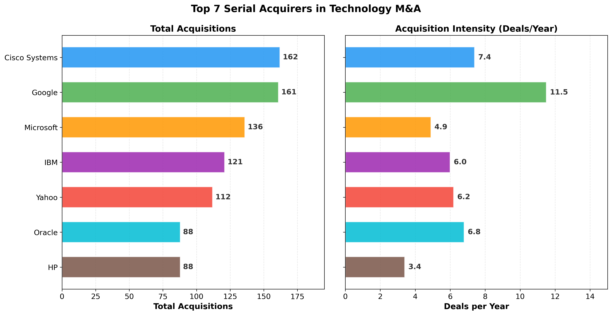
Top 7 Serial Acquirers in Technology M&A
Chart Explanation: This dual-panel chart compares the top seven serial acquirers by total acquisition count (left) and acquisition intensity measured in deals per year (right). While Cisco and Google lead in total volume, Google’s intensity of approximately 11.5 deals per year significantly outpaces all peers [16, 1].
What Drives Serial Acquirers. External research confirms that serial acquisitions are a defining feature of the technology sector. According to an NBER working paper, serial acquisitions — sequences of transactions by the same acquirer within the same or adjacent market categories — constitute approximately one-quarter to one-third of majority-control M&A deals in technology [19]. Cornell University research further indicates that around four in five U.S. M&A deals are made by serial acquirers, predominantly large, publicly traded firms [20].
Performance Advantages. The data strongly supports the serial acquirer model. According to L.E.K. Consulting, serial acquirers outperformed occasional acquirers by more than 11% and organic-only companies by more than 14% on weighted-average total shareholder return [2]. BCG research shows that successful serial acquirers spend more than 5% of entity value per year on acquisitions, grow up to three times as fast as rivals, and deliver nearly double shareholder returns over sustained 15-year periods [3]. The strategic approach has also evolved: BCG’s 2026 analysis finds that dealmaking has broadened from buying technology and talent to assembling platforms and scale [4], reflecting a maturation of the serial acquirer playbook from opportunistic capability-buying to deliberate ecosystem construction.

Leadership and Governance Patterns
Board Composition and Size Disparities. The Founders and Board Members dataset contains 382 records spanning leadership roles across the technology companies in the study. The role distribution includes 222 Board of Directors members (58%), 79 Founders (21%), 72 Advisory Board members (19%), plus a small number of dual roles [13]. A significant structural difference emerges between acquirers and targets: acquiring companies maintain substantially larger boards, averaging approximately 8.9 members compared to roughly 5.5 for acquired companies [13]. Top acquirers like Cisco Systems (19 board members), Yahoo (16), Apple (13), and Microsoft (12) maintain expansive governance structures, while smaller or acquired firms such as Dropbox (3), SanDisk (3), and EMC (3) have minimal board representation [13].
Gender Diversity Gap. Gender diversity in technology company leadership remains critically low. Only approximately 18 of 382 individuals in the dataset — roughly 4.7% — are identifiably female [13]. Of these, 17 serve as Board of Directors members, including notable figures such as Andrea Jung (Apple), Carol Bartz (Cisco), Maria Klawe (Microsoft), and Susan Hockfield (Qualcomm). Only one female founder, Sandy Lerner of Cisco Systems, appears in the entire dataset [13]. This stark underrepresentation highlights a persistent governance challenge that may affect decision-making diversity in M&A strategy and execution.
Governance Quality and M&A Outcomes. External research provides important context on how governance structures influence acquisition success. According to research from Aalen University, insider ownership and multiple board mandates are positively associated with M&A success, while larger boards may actually impede integration efficiency [14]. This creates an interesting tension: while acquirers tend to have larger boards, the governance literature suggests that board effectiveness — not size — drives better outcomes. The Strategic Management Society has documented a “Founder Firm Premium,” finding that founder-CEO-led target firms tend to enjoy higher valuations than their professional-CEO-led counterparts [21]. This premium reflects the market’s recognition that founder-led companies often possess unique cultural assets and innovation capabilities.
Founder Retention and Acqui-Hire Dynamics. The post-acquisition fate of founders and senior leaders is a critical governance concern. Research from Northeastern University and Koç University demonstrates that a lack of fit between acquired know-how type and integration mode has a positive relationship with the premature exit of acqui-hired founders [22]. When acquired startups possess disruptive know-how, the acqui-hire team is more likely to be preserved and integrated as a whole, with the founder assigned to a high-status position to improve retention [22]. A Cambridge University study confirms that a significant proportion of acquired CEOs leave the post-acquisition organization within two years following deal completion [23], underscoring the fragility of leadership continuity in technology acquisitions.

Value Creation Opportunities
Deal Structure Patterns. Analysis of the dataset reveals that cash is the dominant deal structure in technology acquisitions. Of deals with disclosed terms, 220 were cash transactions, 47 were cash-and-stock combinations, and 29 were pure stock deals, with 1,347 deals having undisclosed terms [1]. The prevalence of cash deals suggests that acquirers prefer clean transaction structures that provide certainty to target shareholders and avoid dilution. Notable acqui-hire patterns are visible in companies like Adobe, whose acquisitions of firms such as Ideacodes and Thumb Labs were described as talent-focused acqui-hires for Creative Cloud capabilities [1].
The Value Creation Challenge. Despite the strategic rationale behind most technology acquisitions, value creation remains elusive for a majority of deals. According to BCG, more than half of tech deals add little or no shareholder value within two years of closing [7]. However, the distribution is highly skewed: top-quartile deals generate a relative total shareholder return of approximately 26% [7], demonstrating that exceptional value creation is achievable for companies that execute well. In a Bain & Company survey of 352 global executives, overestimating synergies was identified as the second most common reason for disappointing deal outcomes [24], highlighting the importance of realistic synergy estimation during due diligence.
Revenue Synergy Realization. Revenue synergies represent both the greatest opportunity and the most common shortfall in technology M&A. McKinsey research indicates that the average gap between revenue synergy goals and attainment is approximately 20–23%, with full capture typically requiring three to five years [11, 12]. This timeline mismatch — where boards expect rapid returns but synergies materialize slowly — contributes significantly to perceived deal underperformance. On the positive side, BCG notes that best-in-class SaaS acquirers can achieve cross-sell penetration rates of 10–30% within three years when offerings are sufficiently complementary and differentiated [7]. This suggests that vertical acquisitions in software, where product portfolios naturally complement each other, offer the strongest value creation potential.
Strategic Implications. The dataset evidence, combined with external research, points to several value creation principles. Serial acquirers in networking and software sectors — Cisco (162 deals), Google (161), and Microsoft (136) — have built their competitive positions through frequent smaller acquisitions focused on capability-buying [1, 16]. This approach, which emphasizes acquiring specific technologies or talent rather than pursuing transformative megadeals, appears to correlate with more consistent value creation. The evolution toward platform assembly at scale [4] represents the next frontier, where acquirers seek to build integrated ecosystems rather than simply adding point capabilities.

Technology Integration Risks
Cross-Border Complexity. The dataset reveals that 24.3% of the 1,158 deals with geographic data — 281 transactions — were cross-border acquisitions [1]. The most common international corridors involve U.S. acquirers targeting companies in Canada (39 deals), Great Britain (39 deals), and Israel (27 deals) [1]. These cross-border transactions introduce layers of regulatory, cultural, and operational integration challenges that domestic deals do not face, including differing employment laws, tax structures, and business customs.
The Sector Complexity Factor. The most frequently targeted sectors in the dataset — Software (331 targets), Mobile (132), and Enterprise Software (113) — are precisely those with the highest integration complexity due to overlapping technology stacks, competing product roadmaps, and deeply embedded engineering cultures [16]. Integrating software companies requires reconciling different development methodologies, programming languages, cloud architectures, and deployment practices, making technical integration a multi-year endeavor even in the best circumstances.
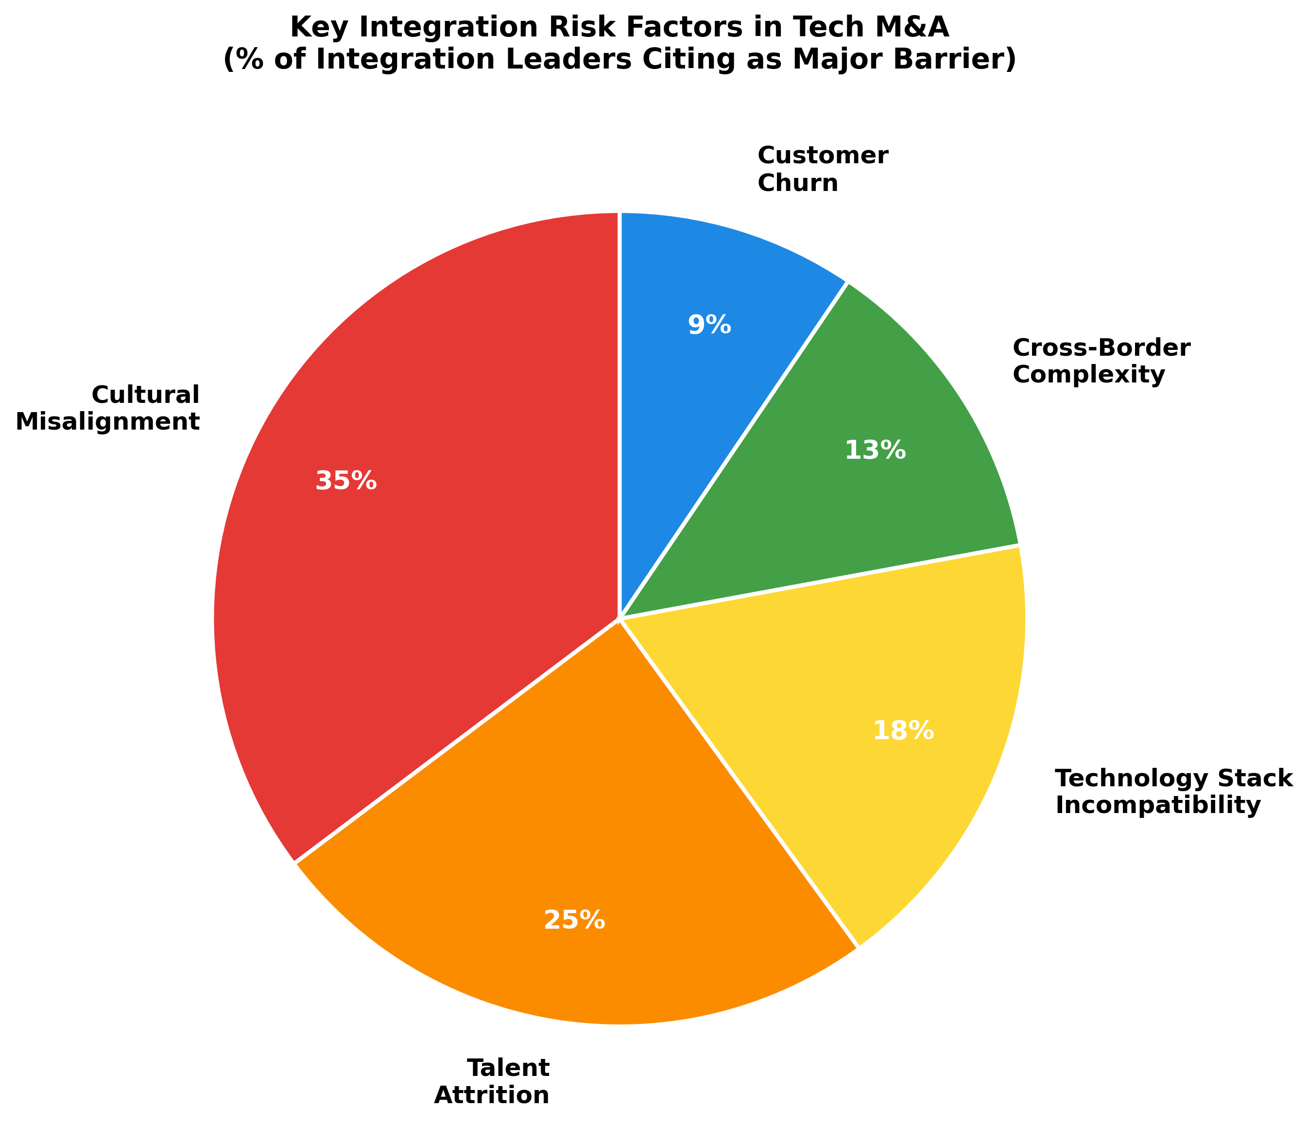
Key Integration Risk Factors in Tech M&A
Chart Explanation: This chart illustrates the relative severity of key integration risk factors in technology M&A. Cultural misalignment is cited as the top barrier by 67% of integration leaders [8], followed by talent attrition affecting 47% of key employees in the first year [9, 10], with cross-border complexity present in about 24% of deals [1].
Cultural Misalignment as the Primary Risk. The historical M&A failure rate has been estimated at between 70% and 90% [25], though a 2025 analysis suggests success rates have improved to approximately 70% due to better leadership and culture-building practices [26]. Cultural misalignment remains the dominant risk factor: a 2025 Mercer survey of 450 post-close integration leaders found that 67% ranked cultural misalignment as the single largest barrier to capturing deal value, ahead of IT integration, customer attrition, and regulatory friction [8]. Cultural misalignment drives an estimated 60% of M&A failures post-close, costing more than $1 million in value in 70% of cases [9].
The Talent Retention Crisis. Talent attrition represents perhaps the most acute risk in technology acquisitions, where human capital is often the primary asset being acquired. Research indicates that 47% of key employees leave within the first year post-merger, climbing to 75% within three years [9, 10]. Replacement costs range from 50% to 200% of an employee’s annual salary [10], making unmanaged attrition extraordinarily expensive. Nearly 40% of companies do not track retention rates beyond the initial 13-to-18-month retention period [9], creating a dangerous blind spot in post-merger integration management.
Mitigation Strategies. Effective risk mitigation requires tailored approaches rather than one-size-fits-all playbooks. According to McKinsey, managing talent should be guided by the specific deal type — acqui-hires, capability acquisitions, and platform deals each require different retention and selection strategies [27]. EY emphasizes that talent integration done right preserves digital deal value and can accelerate the process of combining two cultures into one focused on innovation [28]. The most successful acquirers begin cultural integration planning during due diligence, establish clear retention incentive structures before close, and maintain transparent communication throughout the integration process.

Conclusions and Actionable Recommendations
The analysis across five dimensions reveals a technology M&A landscape characterized by concentrated activity among serial acquirers, significant governance disparities between acquirers and targets, challenging but achievable value creation dynamics, and substantial integration risks that demand proactive management.
For Acquirers, the evidence strongly favors a serial acquisition strategy executed with discipline. Companies that make M&A a consistent part of their growth agenda outperform occasional acquirers by more than 11% on total shareholder return [2] and grow up to three times faster than peers [3]. However, success requires realistic synergy expectations — revenue synergy gaps of 20–23% are the norm [11, 12] — and aggressive early investment in cultural integration and talent retention. Given that 47% of key employees leave within the first year [9], retention planning must begin during due diligence, not after close.
For Targets and Boards, the “Founder Firm Premium” [21] suggests that founder-led companies command higher valuations, making founder retention a strategic asset during negotiations. Boards should ensure that governance structures — including board independence, insider ownership alignment, and diversity — are optimized to support effective M&A decision-making [14]. The critically low gender diversity observed in the dataset (4.7% female representation) [13] represents both a governance risk and an opportunity for companies that prioritize inclusive leadership.
For the Broader Market, the shift from capability-buying to platform assembly at scale [4] signals a new phase in technology M&A. As AI continues to drive deal activity — with over 11,000 AI-linked acquisitions since 2020 [4] — companies must develop integration capabilities that match their acquisition ambitions. The improving but still challenging success rates in M&A [26] underscore that execution, not strategy, remains the primary differentiator between value-creating and value-destroying deals.

References
1. https://us-west-2.quicksight.aws.amazon.com/sn/spaces/f1fd5551-ef3f-4ab9-b55d-da7a87df70c7?documentId=d5d8d633-3127-4424-bc0f-1f1ff0b7cde2
2. https://www.lek.com/insights/post-merger-integration/keys-ma-success-how-serial-acquirers-drive-outperformance
3. https://www.bcg.com/en-au/publications/2014/mergers-acquisitions-unlocking-acquisitive-growth
4. https://www.bcg.com/publications/2026/ai-m-and-a-no-consolidation-yet
5. https://pitchbook.com/news/articles/big-ticket-deals-push-m-a-value-to-all-time-high
6. https://www.mckinsey.com/capabilities/m-and-a/our-insights/technology-media-and-telecommunications-building-the-future-one-deal-at-a-time
7. https://www.bcg.com/publications/2026/tipping-the-tech-m-and-a-odds-in-your-favor
8. https://www.loebleadership.com/insights/post-merger-integration-why-culture-fails
9. https://www.directorsandboards.com/articles/protecting-value-after-the-deal/
10. https://www.clearlyacquired.com/blog/key-employee-retention-best-practices-for-m-a
11. https://www.mckinsey.com/capabilities/growth-marketing-and-sales/our-insights/seven-rules-to-crack-the-code-on-revenue-synergies-in-ma
12. https://www.mckinsey.com/capabilities/m-and-a/our-insights/capturing-cross-selling-synergies-in-ma/
13. https://us-west-2.quicksight.aws.amazon.com/sn/spaces/f1fd5551-ef3f-4ab9-b55d-da7a87df70c7?documentId=94ae9f84-aef1-4a07-ad2b-fcf5b601653f
14. https://virtusinterpress.org/IMG/pdf/cgsrapp21.pdf
15. https://www.feinternational.com/blog/ai-ma-trend
16. https://us-west-2.quicksight.aws.amazon.com/sn/spaces/f1fd5551-ef3f-4ab9-b55d-da7a87df70c7?documentId=1b042806-e128-4471-a484-98d0e496ee39
17. https://momentumcyber.com/cybersecurity-mergers-acquisitions-report-2025/
18. https://www.pwc.com/us/en/services/consulting/deals/library/ai-and-private-equity-fuel-surge-in-mergers-and-acquisitions.html
19. https://www.nber.org/papers/w34178
20. https://news.cornell.edu/stories/2026/06/persistence-focus-tech-makes-us-serial-acquirers-different
21. https://www.strategicmanagement.net/publications-resources/strategic-management-explorer/acquisitions-of-founder-led-firms-risks-and-sources-of-value/
22. https://mackinstitute.wharton.upenn.edu/wp-content/uploads/2021/03/Karim-Samina-Bakir-Beril-and-Ozdemir-Mahmut_Acqui-hires.-Redeployment-and-retention-of-human-capital-post-acquisitio.pdf
23. https://www.repository.cam.ac.uk/bitstreams/56ebcd17-8930-487a-bdce-9f9704b27a04/download
24. https://media.bain.com/Images/BAIN_BRIEF_Why_some_merging_companies_become_synergy_overachievers.pdf
25. https://hbr.org/2011/03/the-big-idea-the-new-ma-playbook
26. https://www.forbes.com/sites/vibhasratanjee/2025/04/01/ma-success-rate-rises-to-70-but-firms-must-navigate-7-essential-missteps/
27. https://www.mckinsey.com/capabilities/m-and-a/our-insights/retain-integrate-thrive-a-strategy-for-managing-talent-during-m-and-a-transactions
28. https://www.ey.com/en_us/insights/strategy-transactions/digital-m-a-three-talent-and-culture-challenges

